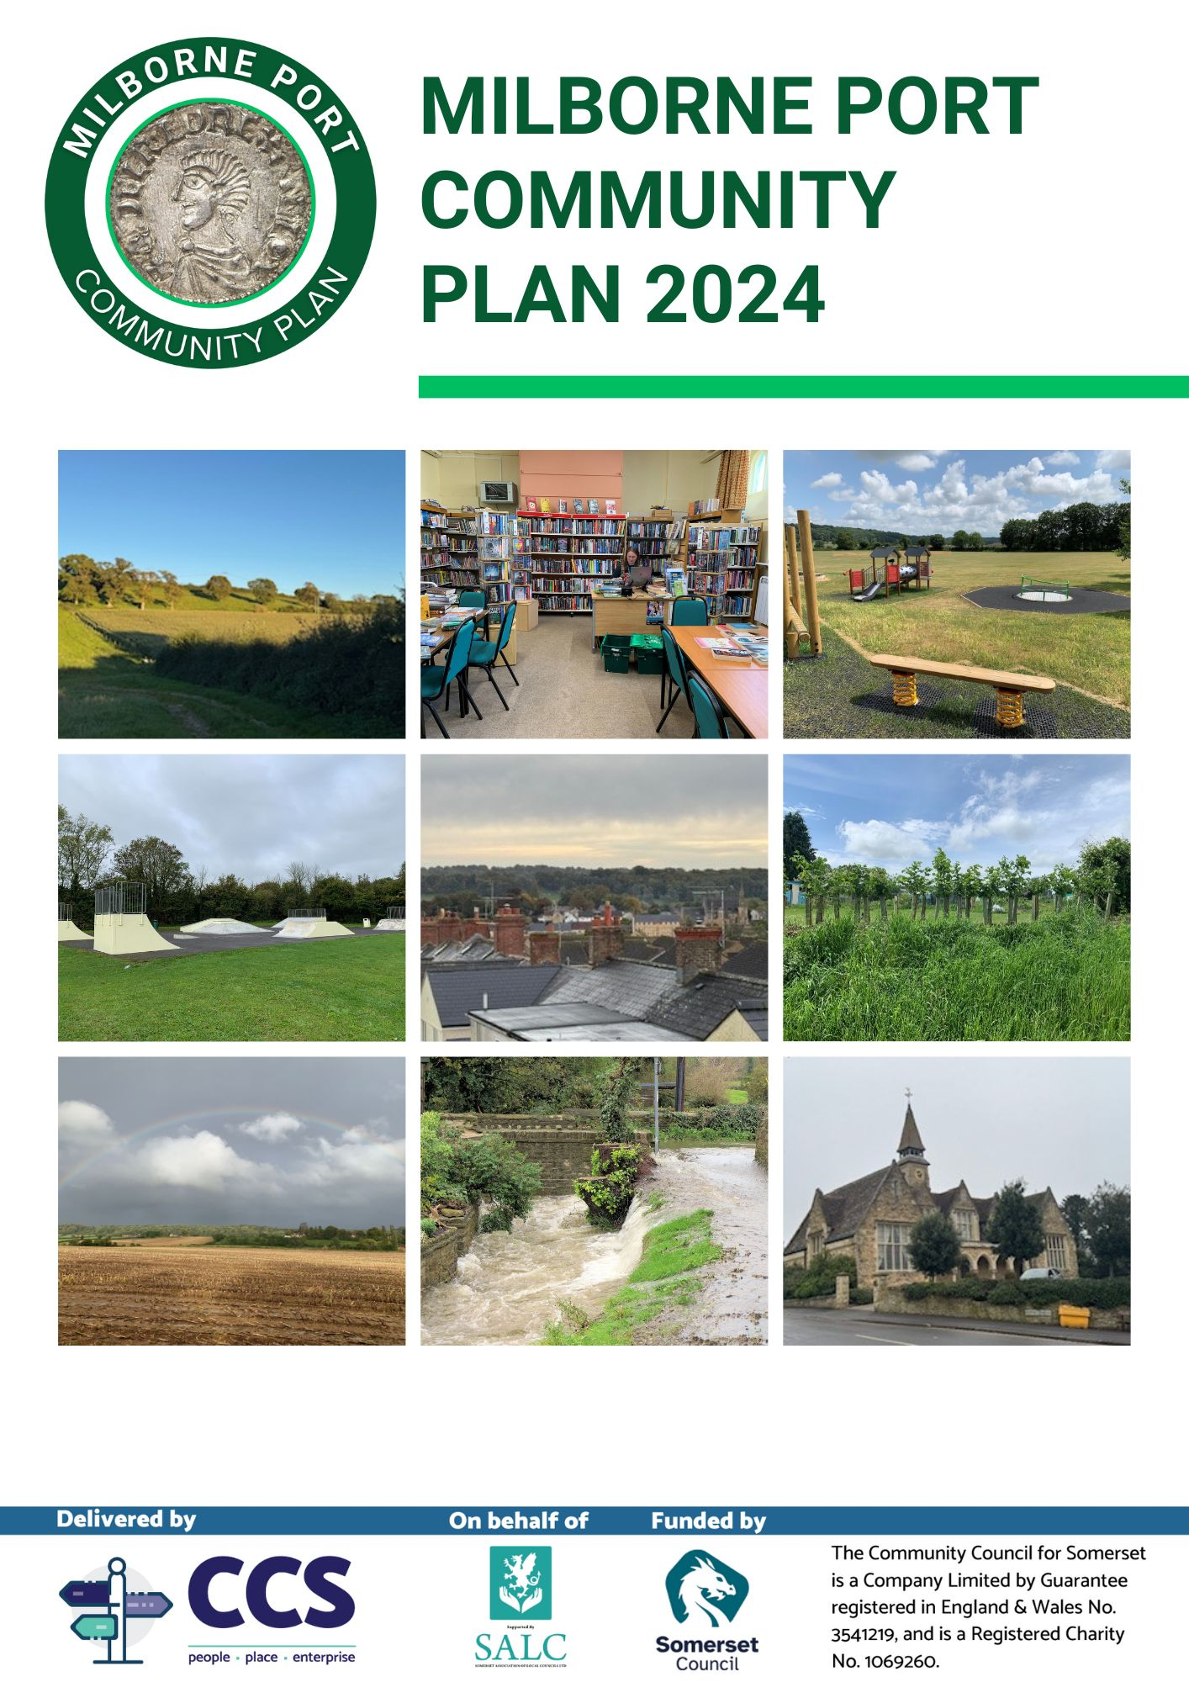

Contents
Executive Summary (available as a separate document)
Report
Introduction | 3
Methodology | 5
Demographics | 6
Your Parish | 9
Traffic, Travel & Transport | 12
Local Environment | 20
Community Facilities & Services | 24
Young People & Children | 33
Housing | 37
Next Steps & Privacy Statement | 43

Appendix 1, survey comments
Action plan (available as a separate document with funding plan)

Introduction
This is the 2024 Community Plan for the Parish of Milborne Port. In it the reader will be able to see what key themes are important for the Parish Council and wider Community stakeholders to consider based on the views of residents. The plan will include the actions that the Parish Council will take and how some of these actions could be funded.
The Parish of Milborne Port lies on the Dorset/Somerset borders, close to the Abbey Town of Sherborne, and nestled between the green and rolling hills of the Blackmore Vale and the banks of the river Gascoigne. The Somerset village has grown to incorporate Kingsbury Regis to the north, and the wider parish includes the hamlets of Milborne Wick and Goathill. It is a large parish with the northwest boundary extending close to Corton Denham, the south down to the Dorset border, and the east and west boundaries marked by the magnificent walks of East and Vartenham Hills respectively
The village has been in continuous occupation for centuries, with prehistoric finds and features discovered on Barrow Hill, an Iron Age Hill fort in the north of the parish. It is featured in the Domesday Book. Milborne Port has a unique built form, with Anglo-Saxon and Norman features, and extensive industrial growth in the eighteenth and nineteenth century as part of the tanning industry. Various parts of the village have been designated conservations area in recognition of their unique history and architecture.
Milborne has a lengthy political history. It was a Royal Mint in Anglo-Saxon times, with a number of pennies from the reign of Aethelred the Unready in the British Museum. It was one of the more “rotten” of parliamentary boroughs, returning two MPs until the 1832 Reform Act. It now sits within the Blackmore Vale Ward for Somerset Council, and the Westminster Constituency of Glastonbury and Somerton.
In 2001 the parish population was circa 2,600, rising to about 2,800 in 2011 and 3,200 in the 2021 census.
Today the majority of people in employment in the parish work outside of the parish boundaries. The decline of the tanning industry, and the introduction of the motor car have also meant that much of the indigenous economic activity of the community has reduced. The extensive levels of new development and the new incoming population, both retirees and young families, mean that the dynamic of the village has evolved, even though the overall population has grown less swiftly than the number of new residences might lead one to expect.
Despite the decline in economic activity, the parish still retains some economic structure with, amongst others, two pubs; a mini supermarket; a Michelin recognised restaurant; an award winning fish and chip shop: a computer system repair shop; a garage and petrol station; a veterinarians; a private health and well-being clinic; retirement homes; a hairdressers; and various professional, health, technology, building, maintenance and design services. There is extensive farming within the parish, and a National Hunt racing stables.

There are pre and primary schools, a Recreation Field with a vibrant football club, together with cricket and tennis facilities; two sizeable children’s play areas, and a number of smaller play parks; Town, Church and Village Halls; a part time library service; allotments; a skate park; Saturday markets; and a number of active community groups. The wider parish has an extensive network of footpaths, some with stunning views over the parish and surrounding countryside, but cycle routes other than roads are limited.
A previous Parish Plan was produced in 2010 based on information gathered by surveys and consultation groups from 2005 to 2009. It gathered survey responses from some 400 residents with particular focus on economic issues, and detailed views from discussions with businesses, stakeholders, and resident focus groups. It contained a brief history of the village, statistical data and an action plan and a process for taking forward the recommended actions. In 2018 the Parish Council performed a survey of residents, garnering an initial 140 responses, and producing initial results, but this never reached a conclusion. In 2019 a group of residents, supported by the Parish Council, gained approval to start a Neighbourhood Plan (more focused upon Planning issues) but despite some initial survey results this was effectively cut short by the pandemic. Reborne Church have also consulted with their stakeholders extensively in the recent past, in part regarding community needs, whilst drawing up plans for the redevelopment of their site on North Street.
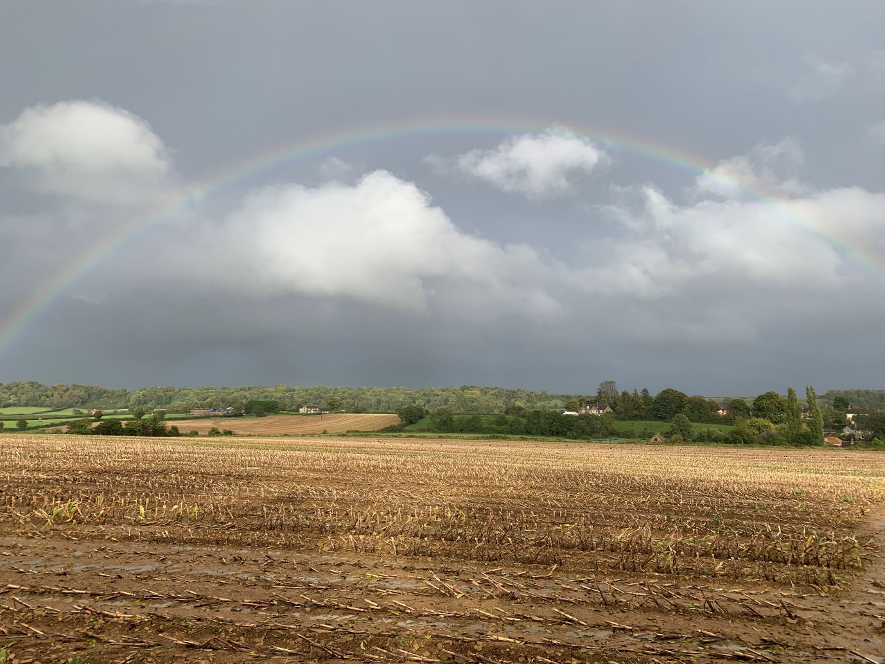
With a number of new properties in the village bringing an influx of new people, the impact of Covid, the cost of living crisis, and the establishment of a new unitary authority, it is now time to establish a new Community Plan that reflects the community we have in the village now.

Rainbow over Kingsbury

Methodology
Mid-way through 2023 the Parish Council were made aware of the opportunity to bid for support from the Charity CCS (the Community Council for Somerset) in the development of a new Community Plan in 2024. In turn this support is funded by Somerset Council, following a first wave of Plans produced in 2023, so Milborne Port Parish Council’s financial commitment has been limited to materials and time. The Parish Council decided to bid for that support and were pleased to be accepted. Following guidance and support from CCS the Parish Council established a small steering group made up of members from a representative section of our community.
The team produced a Communications and Marketing Plan which set out how they would engage the community. This covered establishing what should be surveyed, advertising before the survey went live and communication during its availability. This included the use of social media, posters, traditional leaflets and door to door notification, articles in the Parish Magazine, a banner on the junction of North Street and the High Street and making personal visits to many of the active community groups.
In June 2024 the steering group conducted a mini survey across the community to seek to understand those topics that were felt to be most important at the current time, and hence to be explored more deeply in the survey held in September. This mini survey garnered some 230 responses, and the four most requested topics were: Traffic, Travel and Transport (151); Community Facilities (104); Local Environment (91); and Children and young people (79). We also added a few questions on Planning so as to provide the Parish Council with data to support their responses as a statutory consultee.
CCS supported the team to develop a set of appropriate questions for each topic, in particular the style of question to enable actions to be developed. This became our Community Plan Survey.
The steering group decided that the survey should be on-line only but held open house sessions in the Town Hall during Parish Council hours to allow members of the community unable to complete the survey on-line to do so with the support of members of the steering group.
Prizes for a draw for participants were kindly provided by The Clockspire; Something Else Fishy and Wayne Pullen’s Butchers, which helped incentivise residents to complete the survey.
The survey was completed by 374 people representing circa fifteen percent of our community. Ideally the steering group would have preferred more responses. However, it is a similar sample to the 2005 survey that formed the basis of the 2010 Parish Plan, and with a higher response rate than any survey in Milborne Port since then. It was felt by CCS to be a good response compared to the other communities they have supported, with meaningful data emerging from it.
The steering group would like to thank all residents who completed the mini-survey and the survey proper; all businesses and community groups who helped with posters; the businesses who helped with prizes; CCS for their support; and Somerset Council for their financial investment. We very much hope that you find the survey results and the Plan itself enlightening, and we look forward to taking the findings forward in the future.


Demographics
An introduction to who has completed the survey, including some basic background questions about age, household size and how long they have lived in the area. Please note that Census 2021 data is now available at https://census.gov.uk/census-2021-results

Q1 Where do you live?
Answered: 372 Skipped: 2
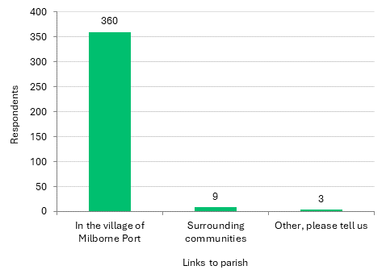
The outstanding majority of respondents live in the village of Milborne Port, with only 9 living in surrounding communities. Other respondents indicated:
- Sherborne
- London
- Used to live in the village but now live less than 10 miles away

Q2 How long have you lived in the Parish of Milborne Port?
Answered: 371 Skipped: 3
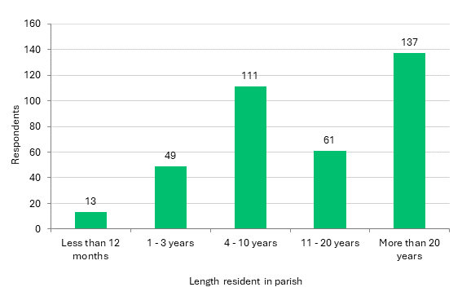
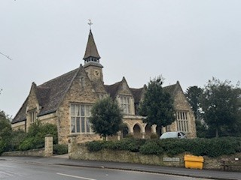
More than half of respondents have lived in the Parish for more than 11 years. A small number have moved to the community since 2021, during or since the Covid 19 pandemic. The smallest groups of respondents are those newest to the Parish.

The Clockspire Restaurant

Q3 What age category do you belong to?
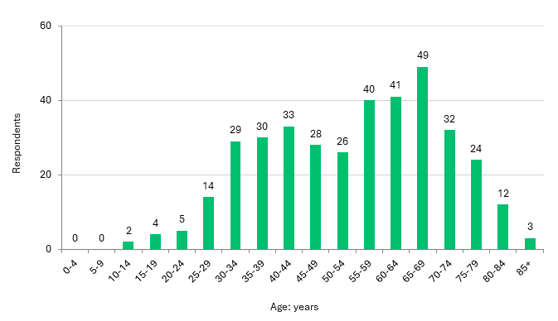
Answered: 372 Skipped: 2

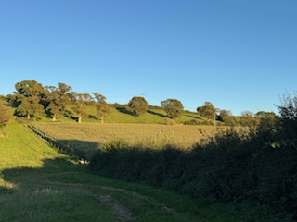
Most respondents to this question are aged 65 – 69 years (49). There is a good range of responses across working age and retirement ages. However, there are notably fewer responses from younger people aged under 30 years.

East Hill


Your Parish Your views on living in Milborne Port and a snapshot of what aspects of the Parish you like and don’t like.
Q4 What do you like the most about living in Parish of Milborne Port? (tick any that apply)
Answered: 372 Skipped: 2
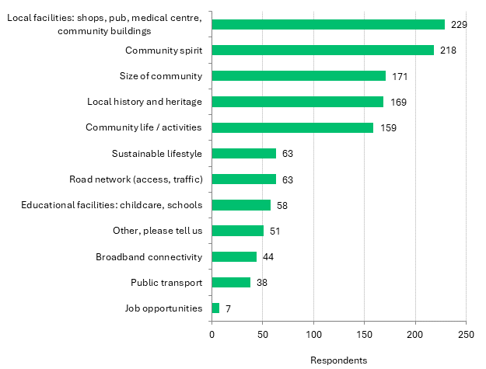
The local facilities are most appreciated by the majority of respondents here (229), followed by community spirit and size of community. Comments highlight the important of access to the countryside, footpaths and local walks, the peace, and also:
- Diversity of people within the village.
- I don't enjoy so much now since the Redcliffe development started, wildlife lost, privacy lost, peaceful environment lost, quiet lost, completely changed the area, also lost security with a unofficial footpath running along between old and new houses with unlocked gate allowing free access.
- My home, my immediate neighbourhood, my children being able to walk to school. Also having a decent butcher and fish and chips shop.
- The fact that many generations and large extended families live here.

What are your main concerns about living in the Parish of Milborne Port? (tick any that apply)
Answered: 367 Skipped: 7
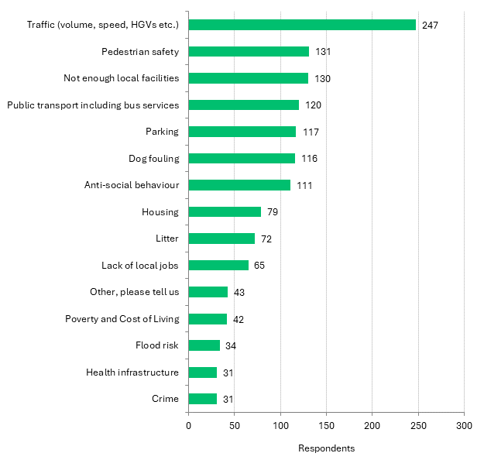
A sizeable majority of respondents are concerned with traffic (volume, speed, HGVs etc) in the Parish (247), followed by pedestrian safety and there not being enough local facilities. There are themes emerging in the comments around the suitability of housing development and the impact of these on both infrastructure (health, education) and wildlife. There are also calls for an active travel route to Sherborne and better childcare provision.
- Beautiful fields we used to walk through are now housing estates.
- Education/early years childcare - no childcare in village for under 2s.
- A footpath/cycle path to Sherborne is needed for public safety.
- Footpaths particularly no path to Sherborne.
- I think as a village we need to encourage sustainable lifestyles. We are so close to Sherborne yet there is no safe cycle route for example. The village would benefit from more facilities (shops) as it continues to grow in size. Better and

- more frequent buses required too to enable those who lack transport and also help reduce traffic volume on our roads.
- Not being progressive enough, open to change, moving with the times : PRIDE events, support for global catastrophies, etc.
- Graffiti in public area and on public items such as electrical boxes, walls, bins.

Q6 What do you think are the most important factors contributing to a thriving community? (tick any that apply)
Answered: 372 Skipped: 2
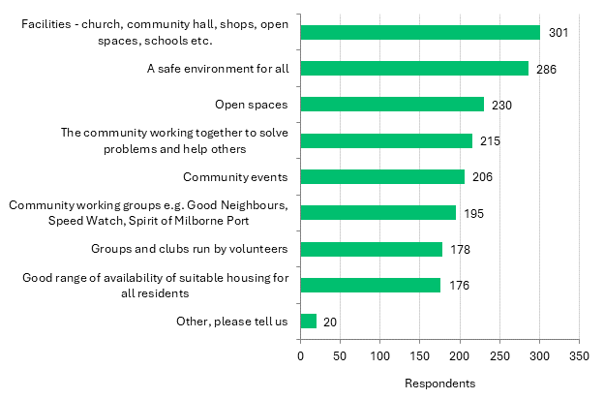
8 out of 10 respondents think that the facilities are the most important factor for a thriving community (301), chiming with majority response to Q2. This is followed by the importance of a safe environment and open spaces. Other comments include:
- All of the above really plus a tolerant and open outlook to especially towards our young people and those who may be struggling in our community.
- Availability of housing not growing beyond what the facilities and access to open spaces can support.
- Fast reliable internet like "GigaClear" to keep everyone connected when needed.
- Increased development impacting on village atmosphere & becoming like any other town without a soul!
- Local library.
- More nature - its lack / absence is bad for our mental well-being and for human life.
- Positive community groups, not those like speed watch which come from a negative standpoint.
- Thriving local businesses.


Traffic, Travel and Transport
Cars are essential for many people in rural areas, but to address the challenges of congestion and climate change, we can look to improve the provision of public transport, and encouraging walking and cycling, to reduce car journeys.

Q7 What concerns, if any, do you have about traffic in the Parish of Milborne Port? (tick any that apply)
Answered: 374 Skipped: 0
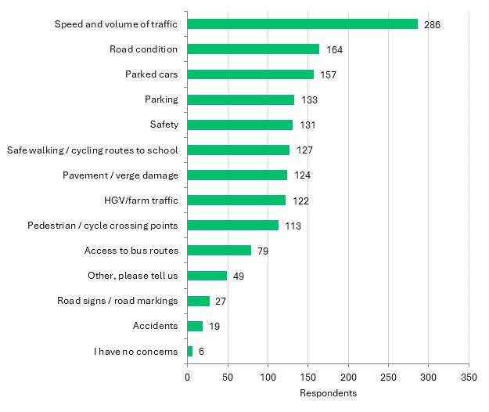
As seen in Q5, a large majority are concerned about the speed and volume of traffic in Milborne Port (286). Parked cars/parking and the condition of roads are also closely aligned as issue of strong concern. Safety is also raised and comments focus on safe crossing points around the school, introduction of 20mph speed limit and active travel options (as in Q5):
- By most schools there is a zebra crossing, I believe it would be beneficial to have one where the lolly pop lady use to be by the school and also along the main road by the butchers. Not only for the school children but the elderly that need use of the chemist and other shops! People drive far too fast and don’t give us a chance!!

- Extremely heavy vehicles along A30. Speeding cars along Station Road & Lower Kingsbury, both should have 20 mph limits and/or speed bumps.
- Gainsborough is the main road to the Surgery and the Co-op but in winter it often freezes and is not gritted making it extremely dangerous and when it rains heavily Gainsborough is like a river.
- Lack of ev chargers on new estates.
- Main road has no safe crossing points and I walk my children across this at least twice a day.
- Need a zebra crossing to cross to the school and the main A30, for the chemist and butchers and for school children.
- No mention of off road routes for equestrians - yet cyclists and pedestrians are noted. All vulnerable road users need to be considered and consulted.
- No pedestrian crossing over A30 near North/South Streets. This would also help control traffic flow on the A30 to allow exits from North and South Streets.
- Parked cars on pavements - difficult for people using mobility items such as walkers and scooters, and difficult for mums with prams having to go into the road.
- As already mentioned, to focus on sustainability (and encourage healthy lifestyles) we need safe pedestrian/cycle routes to Sherborne and a more frequent bus service to Sherborne/Wincanton. This would help our young people given the secondary school connections to these places.
- There needs to be a crossing on the main road by the garage as lots of young people catch school buses there and many walk out without looking.
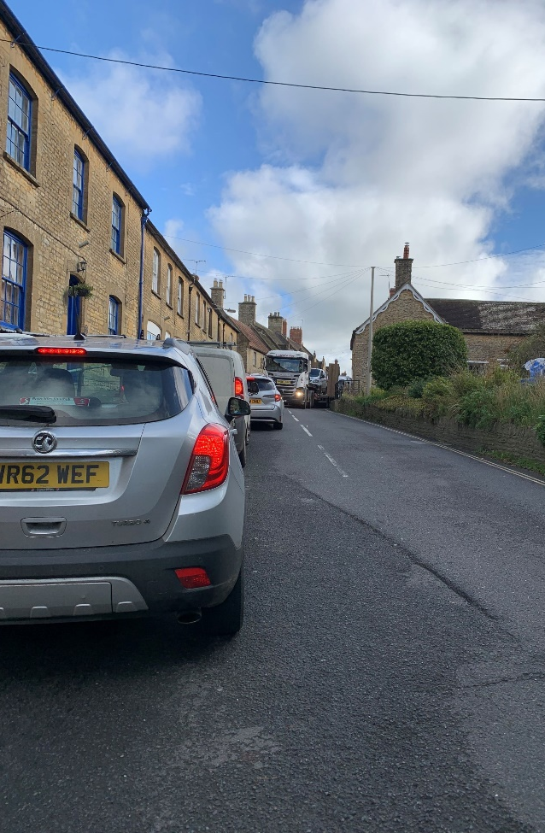
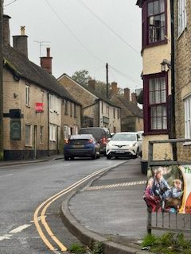
Traffic on the High Street

Q8 What concerns, if any, do you have about the condition of the local roads? (tick any that apply) Answered: 341 Skipped: 33
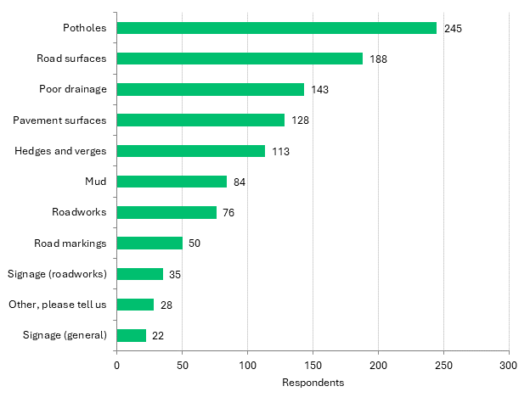
The majority of respondents are concerned with potholes (245), followed by road surfaces and poor drainage. Comments highlight the difficulty in desired standards of maintenance:
- Hedge and trees need cutting back especially by the Co-op.
- Hedges not being cut this year has created blind spots when turning corners.
- Overcutting of hedges damaging wildlife and wildlife corridors; overcutting of verges and public areas of grass along the river or by roads in the village, leaving cuttings lying contributing to the collapse in insect and bird populations which is dangerous for all of us.
- This category (and others) is meaningless without the answers being qualified! Example, yes I am concerned about hedges and verges - I would like them left as they are as much as possible.

There are also access concerns:
- Cars parked on pavements using issues for mobility aids and prams etc.
- Many Pavements are a patchwork quilt of repaired surfaces following Gigaclear and others, and the build-up over the years has resulted in tilted pavements which are difficult for people to walk on with mobility or pushchair needs. I often resort to walking in the road for a flatter surface.
- Pavement surfaces are shocking for walking and pushchairs and those needing wheelchair.
- Wheelchair accessibility needs looking at throughout all pavements in the village.

Q9 What would encourage you to use public transport more? (tick any that apply)
Answered: 323 Skipped: 51
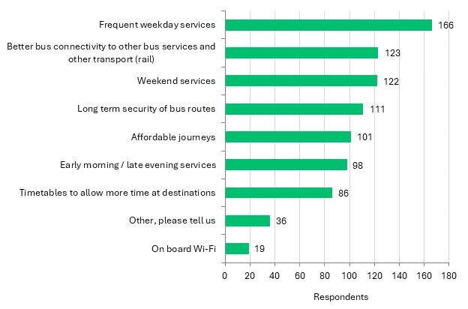
Just over half of respondents with a view would use public transport more if there was a more frequent weekday service (166), followed by better bus connectivity and weekend services. Other comments include:
- Better bus routes through the village would benefit many, but the distance and terrain between the main road and people's homes make it unsuitable for anyone with heavy items, those who are infirm and young children.
- Smaller buses that went round the village not just through it
- A bigger bus on the busiest times as there is never anywhere to sit or space for prams etc
- Accessible wheelchair access
- Benches at bus stops
- bus stop at north end of village
- More buses timetabled 8-9 am and 3-5pm so school kids can use them more readily and are less reliant on cars/parents/ unreliable and expensive school bus
- More information about bus times. Adequate shelter from the weather at bus stops. Free bus pass for pensioners.

Q10 Would better transport options help you access any of these services? (tick any that apply)
Answered: 261 Skipped: 113
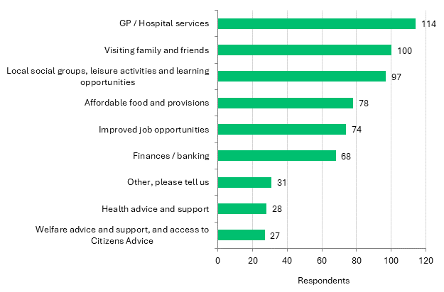
Around 7 out of 10 respondents feel that improved transport options would help them. Most of them feel it would help them access GP/Hospital services (114), followed by visiting family/friends and joining local social groups. Comments highlight the need for better connections to Sherborne (for culture/leisure as well as train connections), Templecombe and Yeovil (for train) and Dorchester:
- I don’t drive and struggle to find work outside the village and around school hours. I also cannot leave the village on Sundays as no buses. Not all buses go to the areas I need even in Yeovil - for example Asda/ the range area.
- We'd like to give up our are entirely. Evening buses and buses to the coast and Castle Cary station would be step for many in that direction.

Q11 Did you know community transport (CAT) is available in your Milborne Port (for those who do not have their own transport or find it difficult to access public transport)?
Answered: 370 Skipped: 4
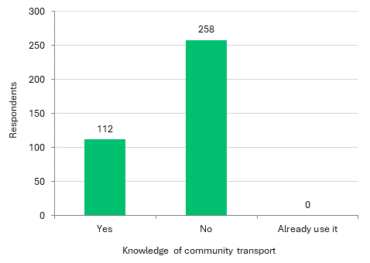
7 out of 10 respondents (258) are not aware of community transport in Milborne Port, suggesting there could be some improvements to promote the service.
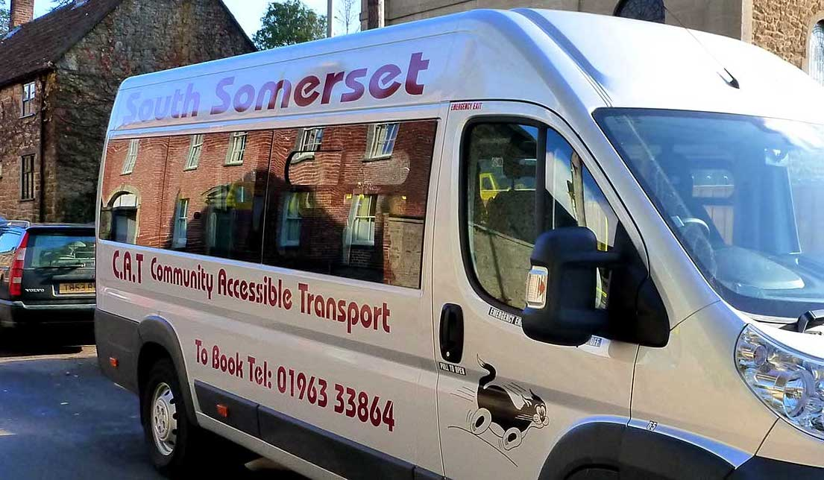
CAT Bus

Q12 What do you think are the best ways to reduce traffic problems in Milborne Port? (tick any that apply)
Answered: 365 Skipped: 9
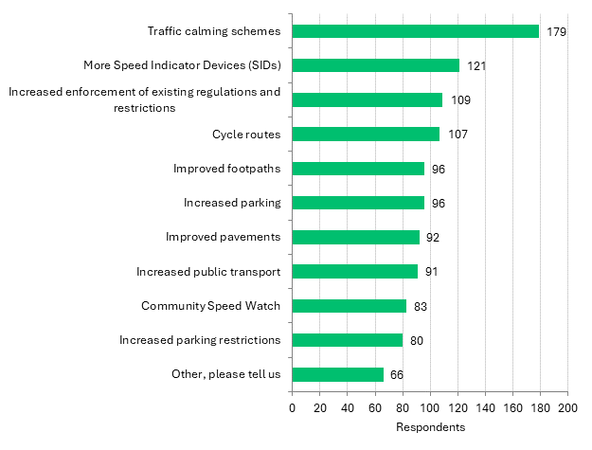
Nearly half the respondents would welcome traffic calming schemes (179) followed by more speed indicator devices and increased enforcement of existing regulations. Several comments highlight the need for new developments to have better parking facilities, introducing more restrictions on parking on the High Street, pedestrian crossings (as in Q7), safer non-vehicle access to the community picnic area and Sherborne (Q7), and the introduction of traffic lights on the High Street.
- A focus on getting kids to walk cycle to school and ensuring key routes to the primary school are safe and free from parked cars. In New Zealand, a local park has a mini road system as a play area so kids learn to ride their bikes in a controlled environment, approaching junctions, going around roundabouts etc, could we set this up at the village hall park for example?
- Planning permission for homeowners should receive more support in the Conservation Area, if they are trying to create safe off road parking. Planning issues are very important but modern life is very different now and a more understanding attitude would really support dealing with parking issues.

Q13 In conjunction with other affected parishes, the Parish Council has supported an application to have the Pinford Lane route from Goathill through the Sherborne Estate into Sherborne confirmed as a public right of way. It is likely for the application to take some time (estimated 5 - 7 years). Do you think the Parish Council should continue to pursue this application?
Answered: 371 Skipped: 3
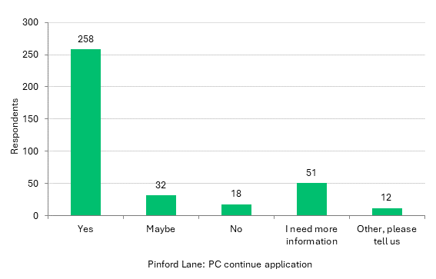
A sizeable majority (258) support the Parish Council in pursuing this application. 51 respondents have asked for more information, which is also echoed in the comments:
- Delighted to hear this - it’s crazy that there’s no obvious way to walk from here to Sherborne. Why though must it take so long? How can this be accelerated?
- I go to Goathill regularly and this is a massive waste of money and time and does not improve the village.
- If a public right of way, please denote what: i.e. footpath, cycle route, bridleway, green lane?
- Needs to be open for all vulnerable users - there has been good work assisted by the British Horse Society have you spoken with them?
- Yes, but only if the route is also made suitable for bicycles with a link to the village centre.


Local Environment
It can be easy to take for granted what you value about your surroundings. Or you may feel you don’t have a say in the changes that might happen. These questions will help you consider what’s important to you about your local environment, including rights of way and shared space in your community.

Q14 Which, if any, of the following issues are you concerned about affecting your local environment in the Parish of Milborne Port?
Answered: 357 Skipped: 17
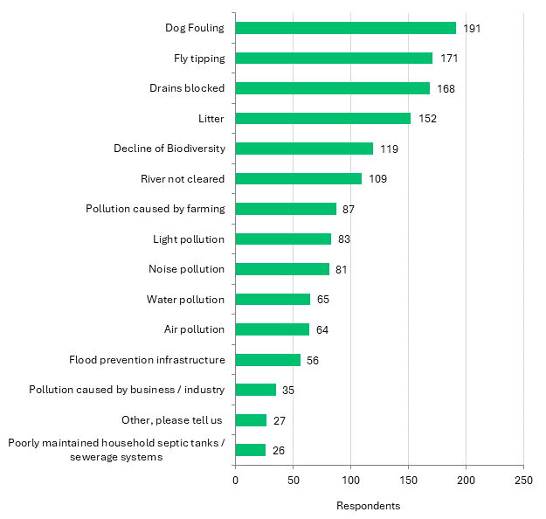
The majority of respondents are concerned with dog fouling (191), followed by fly tipping and blocked drains. Comments raise concerns around the impact of housing development:

- Building on more Greenland in a VILLAGE that has already lost enough Greenland for wildlife.
- Loss of habitat when green belt land used for development.
- Too much new housing being built and not sold. So much damage to ancient hedgerows and green spaces has happened in the last ten years.
- Need more "wild" spaces
The river is also highlighted:
- If the river is uncleared the vegetation slows down the rate of flow, thus allowing more time for the flow into the culvert at the bottom of Brook Street. When the rate of flow is increased the water backs up at this culvert, possibly leading to flooding across the road. As happened in the 1970s. This culvert is a controlling feature for the river through the village.
- The river was always clear and we used to play in it for hours, it looks an awful mess now.
- River pollution caused by sewage.
- Rivers are cleared but not always often enough and pollution and flow are allowed to occur/be affected from Milborne Wick.
Also maintenance of the Rec facilities:
- Tidiness on Rec, graffiti never cleaned, buildings need updating.

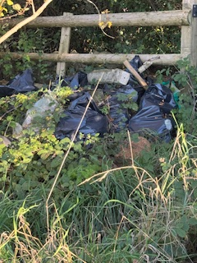
Fly tipping
Dog fouling

Q15 What would improve your experience of using Rights of Way in the Parish of Milborne Port? (tick any that apply)
Answered: 342 Skipped: 32
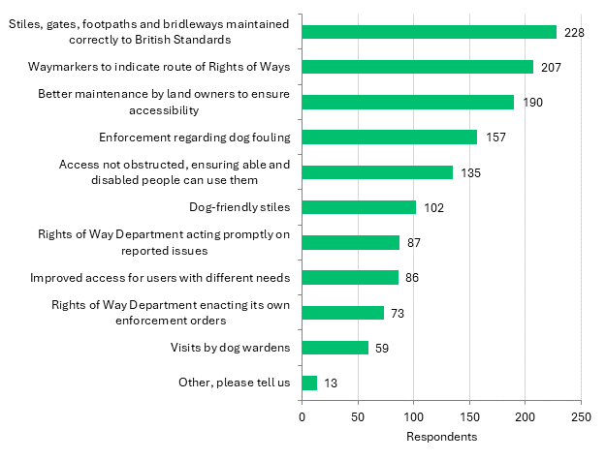
Two out of three respondents (228) want to see stiles, gates, footpaths maintained correctly, followed by waymarkers and better maintenance by land owners.
- A few more poo bins - and I appreciate how good the emptying is btw.
- No cattle in public footpaths so dog walks can be taken safely.
- Paths get muddy and not usable. Need proper paths.
- Reopen Pinford Lane, invest in making other cycle routes accessible.
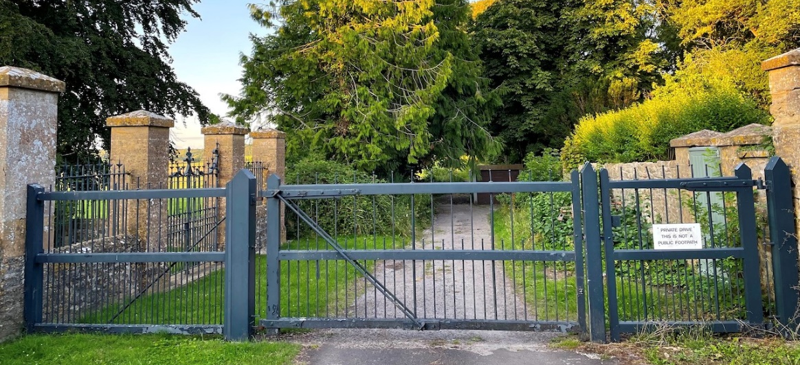

Pinford Lane

Q16 Which of the following activities would you be willing to get involved with to improve the environment, biodiversity and wildlife with Milborne Port? (Please tick all that apply)
Answered: 302 Skipped: 72
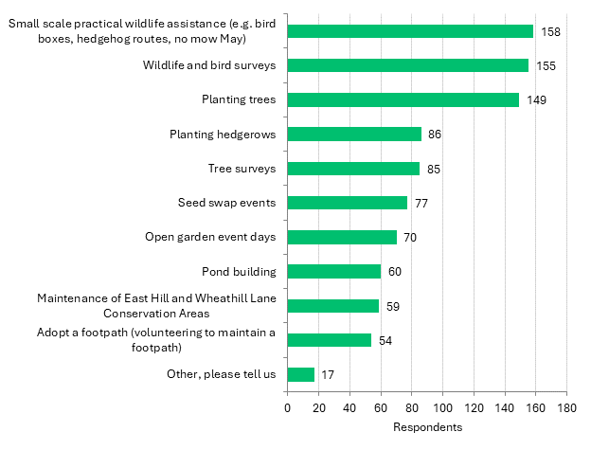
A narrow majority would like to get involved with small scale wildlife assistance (158) or wildlife and bird surveys. Planting trees is also a popular choice for a large number. There are several comments suggesting litter picking, as well as:
- Bloom group.
- Help promote swift boxes and contact developers to demand swift boxes be included in all new developments.
- Picking up litter/dog mess/Springfield rec. Bags and gloves to be made available?
- Promotion of existing wildlife. Why does the parish not publish walking maps highlighting history/heritage and landmarks?
- recycling projects, more litter picking.


Community Facilities and Services
We have a number of community facilities in the Parish, by that we mean buildings, equipment for recreation and places to assemble for meetings, events and social gatherings. These questions have helped us understand whether the facilities are suitable for the community, where improvements are needed or if new facilities are needed.
Q17 Which of the following do you currently make use of in the Parish of Milborne Port?
Answered: 362 Skipped: 12
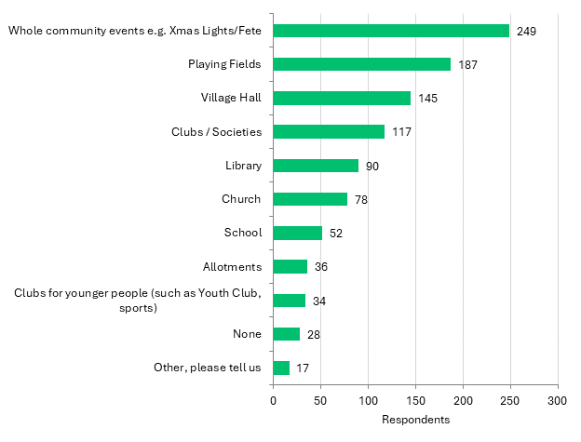
Two out of three respondents (249) take part in whole community events, followed by using the Playing Fields and Village Hall. Other comments include the Spirit of Milborne Port and pubs:
- I would like to join different clubs or classes for yoga etc however most activities appear to be for during the day and I work full time.
- The spirit of Milborne Port have been amazing in the recent years hope we don’t lose it.
- Where is there information about any of these online?

Q18 Which resources in Milborne Port do you currently use? (tick any that apply) Facilities relating to children and young persons are dealt with separately under a specific question later in the survey.
Answered: 373 Skipped: 1
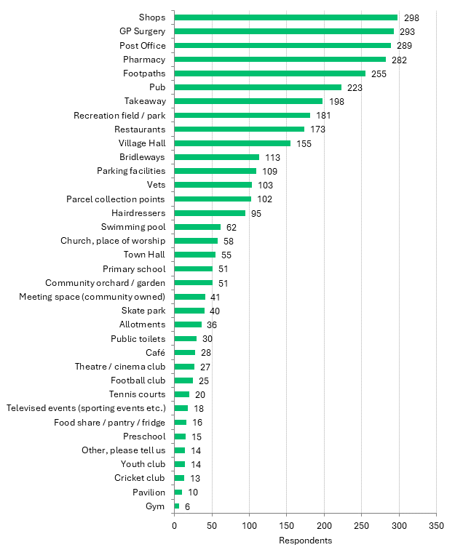
A sizeable majority of respondents use the local shops (298),GP Surgery, Post Office and Pharmacy. Comments indicate that some are not aware of all these facilities on offer:
- Did not know there is a gym?

- I am not aware of many of the above especially the library and café.
- I didn’t know half of these existed!
- There's a gym?!

Q19 Which resources would you use if they were available in the Parish of Milborne Port? (tick any that apply) The Community Hub building is addressed in a separate question later in the survey
Answered: 345 Skipped: 29

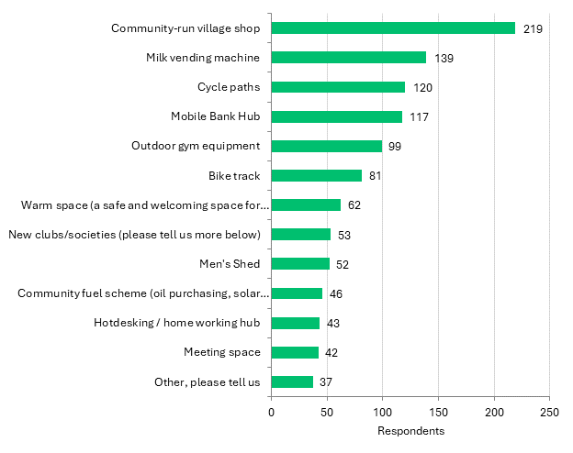
The sizeable majority of respondents (219) would support a community run village shop, followed by a milk vending machine and cycle paths. Comments were grouped around the following themes:
Café/coffee shop, Repair Café, community fridge, community garden:
- Community-run repair shed, affordable home maintenance service, affordable garden maintenance service, a place like the Honesty Jar - but more local.
- Gym (there isn't one I’m aware of), mobility scooter loan scheme, swap shop or charity shop of some sort, cafe (not attached to a pub), book sales.
- A proper cafe and bakery.
- A shop at Wheathill Lane side of village.

Sports clubs: Fitness classes for mums with babies/toddlers, designated dog walking field that’s maintained, walking groups, running club, bike maintenance.
Social clubs: (boardgames, arts and crafts, local easy singing choir, exercise classes for over 60s and their needs, Clubs for mums, baby groups, 12th scale miniatures, flower arranging, sugar crafting, needlework, Creative Writing group, Dance class and choir, cub scouts for children under 11.
- Would like evening activities, film club, knit and natter, maybe a games night (not quiz) something to join when you finish work.
- Would like to see a greater variety of clubs/social events for those who work. Things like yoga, Pilates, meditation.

Q20 Should there be more / new leisure and recreation provision in the Parish of Milborne Port for any of the following specific ages or groups? (tick any that apply)
Answered: 279 Skipped: 95
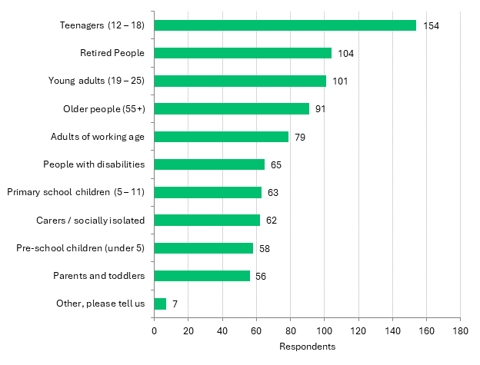
The majority of respondents answering the question would welcome more provision for teenagers (154), followed by retired people and young adults.
- Lack of fun sports for all groups. Only seems to be football or cricket available for youngsters in a growing village. Needs to be more diverse. No evening sports groups available for women/mothers. Have to leave the village to attend groups/gyms etc.

- Noticeable that we hardly saw any young children around during summer holidays. Think playschemes and parent/toddler groups are needed.
- SEN children.
- The Village green on Gascoigne Park should be turned into an after-school meeting area with benches and a low wall all round it so that the children can scoot about without accidentally scooting down the bank and into the road. It could be made a lovely safe place to gather for very little outlay.
- Would be nice to have some 'gym' or keep fit equipment somewhere for older people to exercise on or enjoy, such as a swing, rowing machine, bars etc.
- Young carers.

Q21 What would help you to take part in more social or community activities in Milborne Port? (tick any that apply)
Answered: 311 Skipped: 63
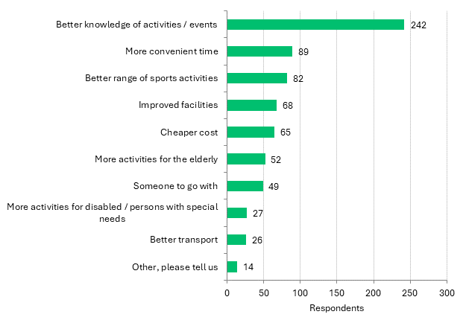
A large majority of respondents with a view say that they need better knowledge of activities/events to take part (242) , followed by more convenient times and a better range of activities.
- Having one source of information about social group/activities.
- I never know what’s on or how to find out!

Q22 Which sport that is currently not available in the Parish would you like to see available?
Answered: 108 Skipped: 266
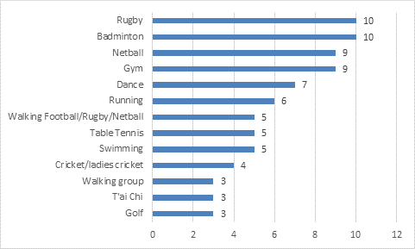
- Anything that accommodates SEN children.
- Not sure which sports ARE available. How would I find out?
- Women’s anything!!!
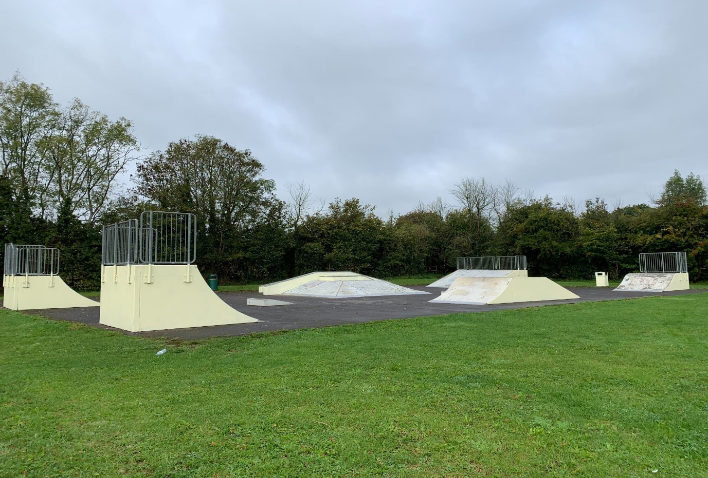
In addition, there were one or two comments each for archery, basketball, boccia, body balance, boot camp, boules, croquet, cycle paths, girls football, inflatable sessions for children, karate, kurling, lawn bowls, ludosport, motorcross, orienteering, outdoor bowls, pétanque, pickleball, Pilates, speedway, squash, Winter/ all year Astro football pitch, yoga, Zumba.
Milborne Port, Skate park

Q23 What facilities should be considered for future investment within the Parish of Milborne Port? (tick any that apply)
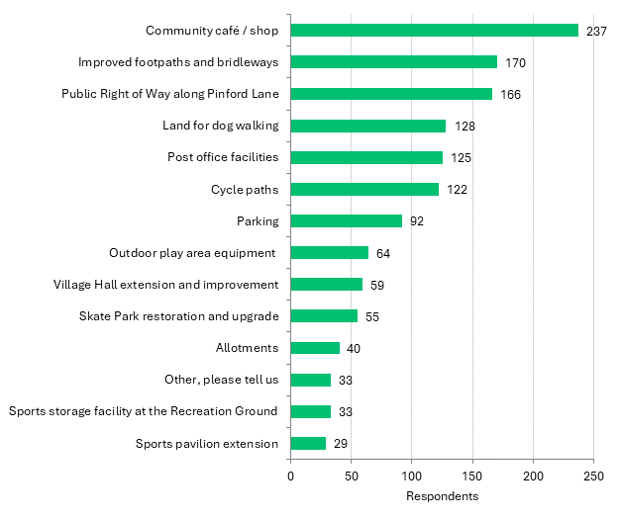
Answered: 365 Skipped: 9
Nearly two out of three respondents (237) would support investment in a community café/shop, chiming with findings in Q19. Followed by improved footpaths and bridleways (see also Q15) and the proposed public right of way along Pinford Lane (see also Q13). Other comments include:
- A non-profit gym where it’s 24hour and unlocked with a fob. 70% goes back into the community and 30% going into new equipment or maintaining the gym. Elderly and students get discount.
- Definitely improving the skate park for the youth, that is a must. Sherborne skate park is so much better.
- Facility for teenagers.
- Have MUGA area back to basketball facility now the tennis courts are open for all to use and done so nicely for our community, young people would love this space back to play.
- I would really like having a newsagents again or more shops and cafés in general.
- Indoor play area for children in Winter.
- Lack of commercial units in the village. These are never thought about this has led to a lack of job opportunities.
- Larger library in own building.

- More community projects like freecycle events, swap shop- it may reduce fly tipping and help people to reuse.
- Shelter at Gainsborough Park.
- The Redcliffe Homes Community Hub.
- We need a dog park. We need more walking trails that can take strollers or wheelchairs
- Wider access to swimming pool.

Q24 The Village Hall Committee has expressed interest in improving the infrastructure of the Village Hall. Please tell us what improvements you would like to see made to the building (tick any that apply)
Answered: 271 Skipped: 103
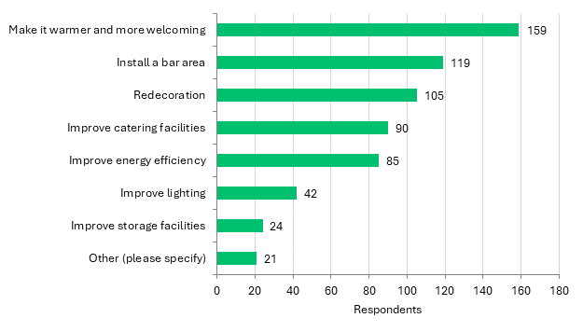
The majority of respondents answering the question would like the hall to be made warmer and more welcoming (159), followed by installing a bar area and redecoration. Other comments include:
- A place for spectators of those watching the sports (mainly football) to be able to buy food and drink. There are so many football teams playing at the rec it is absolutely screaming out for this facility to become available.
- Acoustic improvements the hall is not great for sound.
- Cheaper for residents.
- Improve Ladies toilet area and Disabled toilet.
- It’s quite ugly inside, people use it for wedding receptions, but it’s not a nice building to look at, inside or out.
- More comfortable seating.
- Open a village shop on site.
- Replace the front entrance with something less 70’s! And more energy efficient!
- Small room availability sometimes you don’t want to whole hall it’s too big for parties etc, so you end up using the church house.

Q25 How would you like the new Community Hub on Station Road to be used?
Answered: 339 Skipped: 35
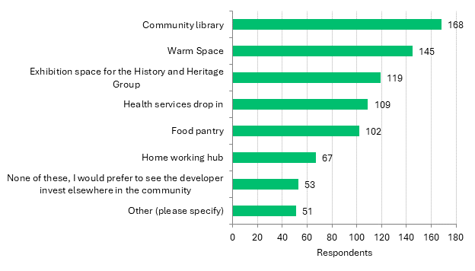
Most respondents would like to use the new Community Hub as a community library (168), followed by a Warm Space and an exhibition space for the History and Heritage group. Also popular are use of the hub for health services drop in and food pantry provision. Some comments raise the hub as a location for the community café and shop, with other suggested functions including:
- Banking hub.
- Community shop if a shop is not otherwise built on that site - there is every chance it would dramatically reduce the number of short car journeys across the village (to the other co-op) alternatively put in a youth club but only if it comes with fully-funded profession youth workers to run it.
- Gym and other businesses that boost the local economy and small industrial units for sale for small businesses to give apprenticeships and jobs to people in the village
- Hold events such as toddler groups or all ages throughout the week. Perhaps that side of the village would benefit from a shop for essentials.
- Safe Meeting Space for any age. Regular Holistic Health and Wellbeing Sessions
- Swap shop, cafe, recycling projects that fund the project (look up terracycle- you could have recycling collection points there that would bring money into the project)
- Youth club with better facilities.
- Youth drop in support centre.
- Investment in what we already have. Currently there are multiple options that have been developed all with good will. Proper maintenance and management of these facilities would serve the community best.
- Let the developer pay for the refurb of the village hall!
- Put the above into the village hall.


Young People and Children
We want to offer children and young people in Milborne Port or who visit the Parish the best possible services so we can provide families an enriching experience. Having your opinions on current services and facilities now enables us to plan future services for children and young people.
Q26 Do you have children and young people in your family who live or regularly visit the parish of Milborne Port? If yes, please answer the following questions. If no, please move on to the next section:
Answered: 365 Skipped: 9
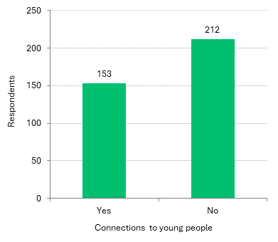
153 respondents to this question have connections to children and young people. We have cross referenced their responses so they are the only results considered in Q27 – Q29.
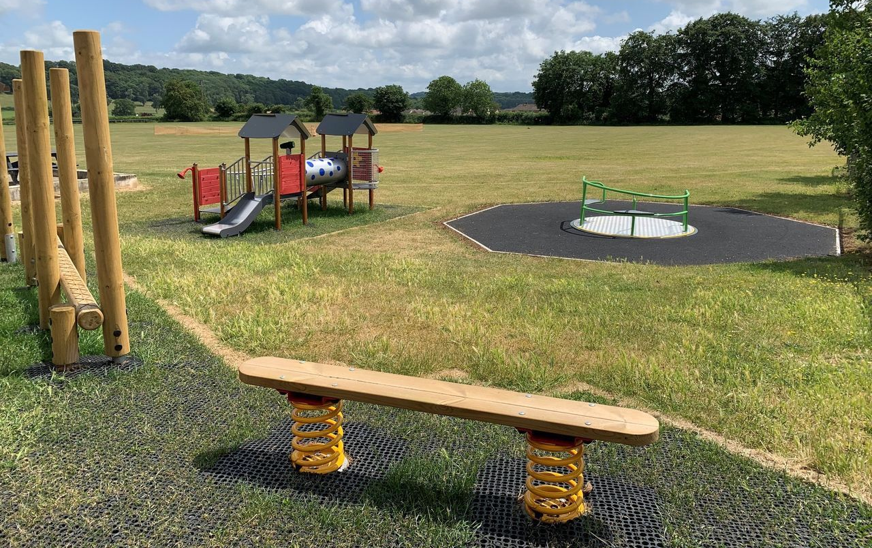

Q27 Which of these facilities and activities do children and young people currently use in the Parish of Milborne Port? (tick any that apply)
Answered: 153
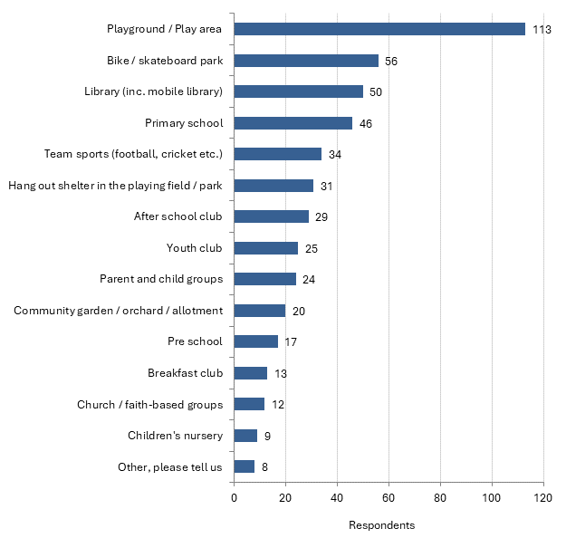
The large majority of respondents to this question with connections to young people use the playground/play area (113) followed by bike/skatepark and library/mobile library.
- There are no parent & child groups other than church based ones, there is no nursery, afterschool clubs are poor, playgrounds have massively improved but no shelter from rain now in the village hall park.

Q28 Which of the following would young people use if they were to be provided in the Parish of Milborne Port? (tick any that apply)
Answered: 153
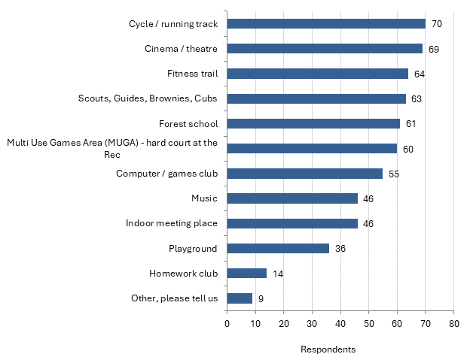
Responses to this question were closely matched amongst the 153 respondents with connections to children and young people. A cycle/running track was most popular (70), closely followed by cinema/theatre, fitness trail, Scouts/Guides etc, Forest School and Multi Use Games Area. Other comments include:
- I don't think kids need more specialist facilities, they need connectivity to Sherborne, Wincanton, Yeovil etc. It takes a village to raise a child and too often it seems that adults find it easier to throw public money at facilities rather than actively engage with kids and involved them in everyday community life.
- Things which are not just sports based.
- We need events for youngsters who are starting to be independent but still need a safe environment, e.g. Saturday afternoon cinema club. A place to hang out after school when parents may be at work.

Q29 Which, if any, of the following prevent children / young people from engaging in activities more generally? (tick any that apply)
Answered: 153
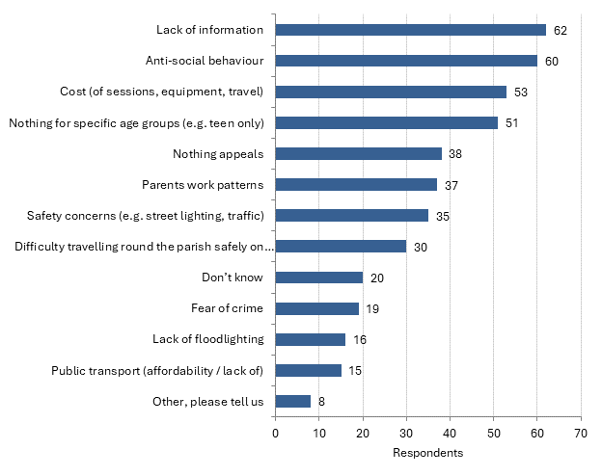
Lack of information is cited as the biggest barrier to children and young people taking part in activities (62), followed by anti-social behaviour, cost of sessions and there being nothing for specific age groups. Other comments include:
- A lot of the events in the village are aimed at children at the primary school. If your child doesn’t attend the school the info doesn’t seem to get through about events.
- Currently there is very little available, and families are having to use other towns & villages to engage & entertain youth. The village is growing & expanding and it would be lovely to see more diverse activities & playdays focused on youth.
- No inclusive activities for SEN children.


Housing
This overview of your needs and current housing situations will help inform the decisions made by the Parish council on planning applications for both large and small developments. Please not this is not a housing needs survey so will provide indicative information only.
Q30 If your current housing is not suitable, please tell us why? (tick any that apply)
Answered: 56 Skipped: 318
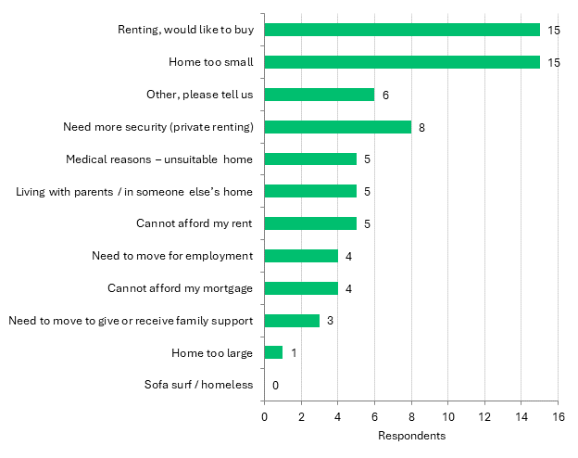
For those who consider their current housing situation unsuitable, many are renting and would like to buy, or feel their home is too small (15 in each case). Other comments include:
- We rent, our housing situation is precarious currently, awaiting news if we can stay.
- Parking is becoming very limited on East Street.
- Parking issues, cannot afford to have a drive at the front of the house.
- Too noisy now and lack of privacy.

Q31 It is likely that Milborne Port will be allocated a guideline figure for additional residential housing in the revised Somerset Local Plan. If development is required, what type of housing would you like to see over the next ten to twenty years? (tick any that apply)
Answered: 324 Skipped: 50
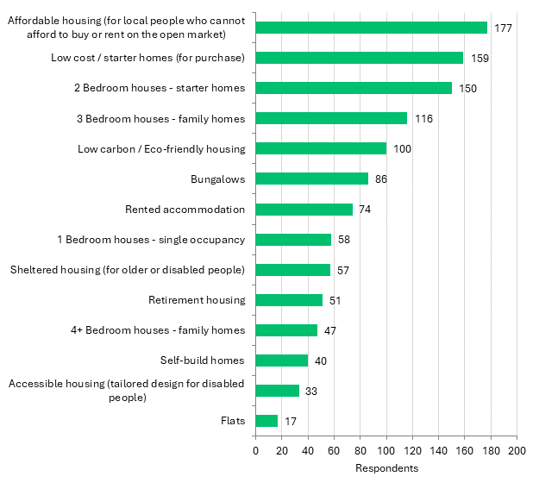
The majority of respondents with a view would like to see affordable housing for local people who cannot afford the open market (177) followed by low cost/starter homes and 2 bedroom starter homes.

Q32 What is important to you in the design of new build housing? (tick any that apply)
Answered: 348 Skipped: 26
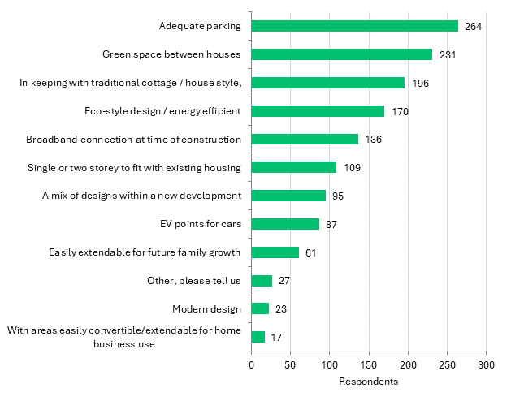
A large majority of respondents say that adequate parking is important in the design of new housing (264 - see also Q7, Q8 and Q12), followed by green space between houses and being in keeping with traditional style.
Comments include both those supportive and critical of development:
- ALL housing should be designed to be accessible to disabled people.
- Development should be small scale and near A30 main road.
- Small blocks of flats (2-storey) with balconies for plants and community gardens planted with fruit and nut trees and with allocated spaces for residents to grow veg.
- Well-designed high density housing in a development pattern suitable for a village, not suburban sprawl.
- Outdoor space - houses not squashed together with miniscule gardens.
- Solar panels or photovoltaic tiles on all roofs and not solar panels on farm land.
- Don’t want more building of homes. Infrastructure is not good enough. Milborne Port is growing into a town not a village. We will move.
- Don't care really now, the village and our area has been spoilt, any more development will simply increase all issues that planners ignore.

- No new housing in Milborne Port. We are getting too crowded as it is and losing our open spaces. We do not need any more new developments.
- Not built on green sites - use brown sites, and make sure that the infrastructure can support the newly built areas (roads, parking, doctor, schools, shops, etc).
- Not in the middle of the village but along the main road where there is more access for large vehicles.
- The village has had its fair share of development and can stand NO more without a major increase in services, the surgery is full, as is the school, build somewhere else!
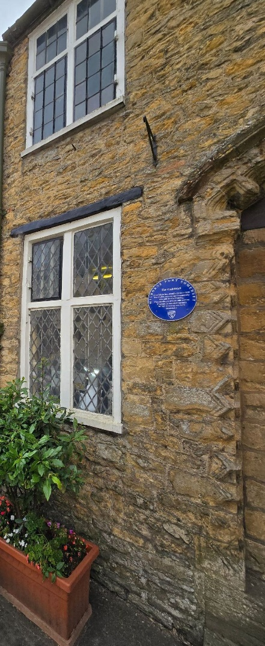
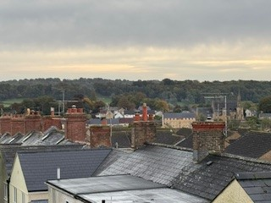
Milborne Port, roof tops

Guildhall - headquarters of Commonalty housing charity

Q33 What sites within the Village of Milborne Port do you feel would be best for future housing development? Somerset Council are in the process of creating a new Local Plan which will set out the guidelines for development in future years. It is likely that an allocation for additional residential development in Milborne Port will be included as part of this new Plan. Can you please indicate those sites, if any, where you believe it would be appropriate for there to be substantial housing development, excluding those already approved/constructed, in the future:(The map above is from the most recent – 2018 – Housing and Employment Land Availability Assessment – HELAA performed by South Somerset District Council). https://surveymonkey-assets.s3.amazonaws.com/survey/519179777/rte/8643122b-8b18-405e-afa5-ea3737f56c6f.PNG
Answered: 259 Skipped: 115

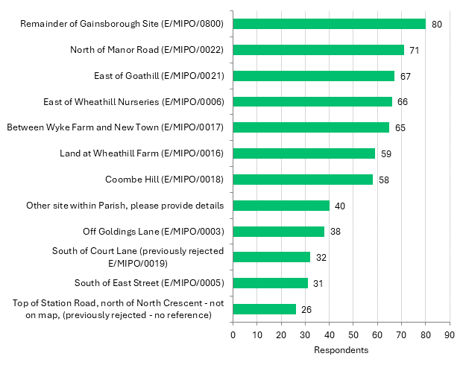
For those answering the question, the most popular option listed for future housing development is the remainder of the Gainsborough Site (80), followed by North of Manor Road and East of Goathill. Some of the comments say that the map offered in the survey was not legible.

More than half of the comments do not support any future development, citing impact on infrastructure and community feel (see also Q5):
- Best I move, this is simply shocking. So sad as the village WAS a hidden gem.
- No more building in This village. Don’t turn it into a town.
- NONE - there have been enough houses built. Where is the employment land propositions???
Other comments include:
- Avoid the east, Wheathill area due to amount being built in this area and inadequate roads for road users and pedestrian safety.
- Development should be small scale and spread across entire local plan period, not front loaded.
- Milborne Wick.
- Move Johnsons out and redevelop the site for live/work units and a cafe, art gallery. Please, if all the Tizzard sites are approved, it should be conditional on building a ring road round the outside to join up with the A30 at Venn House at one end and Wheathill Lane at the other, with a possible extension in future towards the solar farm and old Bowden Way.
- Please do not build any more on the east side - the roads cannot take any more traffic.
- Single infill plots.
- South of old village bounds towards the sewage farm.
- Stop the substantial developments. Have small developments all around the village.
- Where there is easier access to main roads and if possible not using agricultural land.

Next steps
The Steering Group is now developing an action and funding plan to delivery on those issues raised by the community through this work. This will be the focus and priority of the Parish Council over the next couple of years as they oversee the actions which ideally are undertaken by the most appropriate community group or individuals. The Parish Council will review progress against actions on a regular basis and will include an update in its annual report.

Privacy Statement
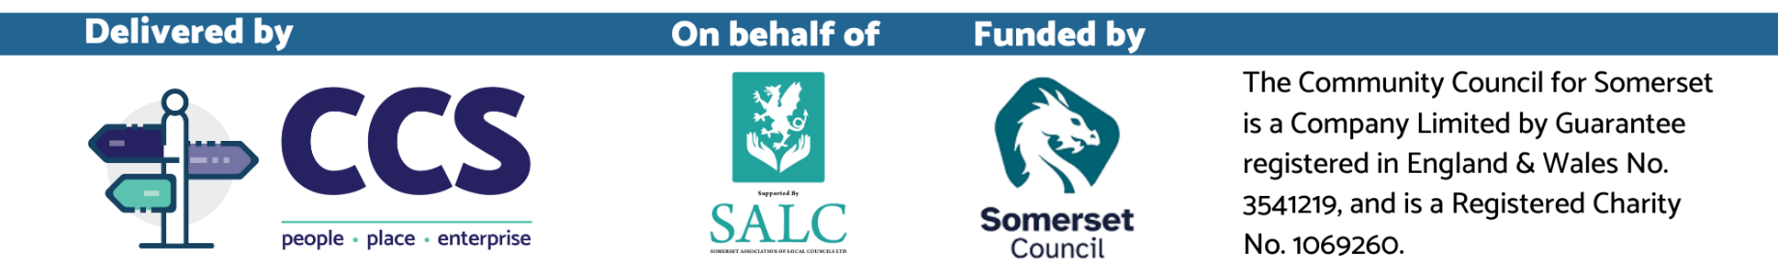
Analysis is conducted by Community Council for Somerset (CCS). Data is captured for legitimate and contractual purposes. Information is collected and analysed in accordance with Community Council for Somerset’s role as a Data Controller and Data Processor.
Data is shared in accordance with the Data Sharing Agreement between CCS and Milborne Port Parish Council.
Milborne Port Community Plan Steering Group entered any paper copies using standard proprietary online survey software. Once entered all paper copies were destroyed.
Digital copies are retained for 12 months and deleted after this period. Any personal data that is captured is anonymised with the report and held securely for the purposes of analysis.
No data will be published which can identify an individual without their consent. If you have provided contact details to offer help, this data is shared with Milborne Port Community Plan Steering Group. If you have entered your details to take part in the prize draw and you won, your data was shared with Milborne Port Community Plan Steering Group.
If you would like to find out more about how we use your data or want to see a copy of information about you that we hold, please contact info@somersetrcc.org.uk or call 01823 331222. Protecting your Personal Data is important and we fully comply and adhere to the Principles of Data Protection set out in our Data Protection / Privacy Policy visit: https://ccslovesomerset.org/data-protection-policy/ and https://ccslovesomerset.org/privacy/

